UNIT IV
PERIPHERAL INTERFACING

*******************************************************************************************
Study on need, Architecture, configuration and interfacing, with ICs: 8255, 8259, 8254, 8237, 8251, 8279, - A/D and D/A converters &Interfacing with 8085& 8051.
**************************************************************************************************
- Introduction:

Data Transfer Techniques

Data transfer may take place between two devices.
For e.g.
- Microprocessor and memory
- Microprocessor and I/O device
- Memory and I/O device

Classification of data transfer techniques
- Programmed data transfer
- Direct Memory Access (DMA)
Programmed data transfer

- Data is transferred from the I/O device to the microprocessor or memory.
- Data is transferred under the control of the program stored in the program memory of the microprocessor based system.
- This technique of data transfer is normally used if the size of data to be transferred is small.
Programmed data transfer techniques is classified as
- Parallel data transfer
- Serial data transfer
- Synchronous data transfer
- Asynchronous data transfer
- Interrupt Initiated data transfer
Comparison of Parallel/ Serial

Parallel | Serial
- 8 bits of data tranferred at a time  - 9 lines required to connect two devices  - Advantageous over small distances | - Only 1 bit of data is transferred at a time  - 2 lines required to connect two devices  - Advantageous over long distances

Comparison of Asynchronous/ Synchronous Data Transfer techniques

Asynchronous | Synchronous
- Used to transfer one character at a time  - Start and stop bits are used with each character  - Speed is less  - Transmitter and receiver can use two separate clock inputs | - Used to transfer a block of  characters at a time  - No start/ stop bits are used  - Speed is high  - Transmitter and receiver share a  common clock

- Interrupt Initiated Data Transfer
- Microprocessor initiates the interrupt mechanism and starts executing the main program.
- I/O device informs the microprocessor that it is ready by generating an interrupt signal.
- Microprocessor services the interrupt by completing the data transfer.

- DMA Controlled Data Transfer
- DMA stands for Direct Memory Access
- used when large amount of data is to be transferred
- Microprocessor does not participate in this type of data transfer
- Data is transferred directly between an I/O device and memory or vice-versa
- Data transfer is controlled by an I/O device or a DMA controller
- DMA data transfer is fast as compared to programmed data transfer

************************************************************************************************************
Describe the internal block diagram of 8255 / PPI .(December 2010) (April 2018)(December 2017)
Explain the functioning of 8255 programmable peripheral interface and its modes. [April/May 2017, May/June 2016, April/May 2015, Nov/Dec2015,April/May 2011,May/June 2014,May/June 2013,Nov/Dec 2013,May/June 2009]
*********************************************************************************
. 2.Parallel communication interface (8255)(Programmable peripheral interface)
Definition:
The 8255 is a general purpose programmable I/O device used for parallel data transfer. It can be programmed to transfer data under various conditions, from simple I/O to Interrupt I/O. It is flexible, versatile and economical when multiple I/O ports are required.
Functional Block Diagram
The 8255 consists of four sections namely,
- Data bus buffer
- Read/write control logic
- Group A control
- Group B control

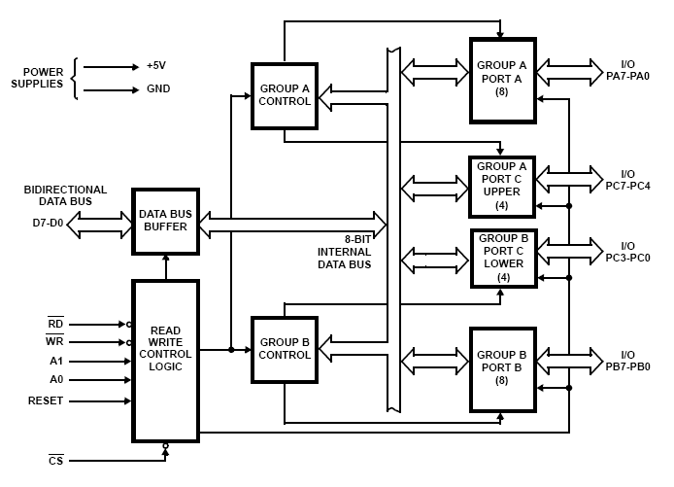
Figure. Block diagram of 8255 Programmable Peripheral interface.

DATA BUS BUFFER:
- This is a tri-state, bi-directional data bus used to interface the internal data bus of 8255A to the system data bus of 8085.
- Using IN or OUT instructions, CPU can read or write the data from/to the data bus buffer.
- It can also be used to transfer control words and status information between CPU and 8255A.

READ/WRITE CONTROL LOGIC:
- This block controls the chip detection (CS), read (RD) and write (WR) operations.
- It consists of A₀ and A₁ signals which are generally connected to the CPU address lines A₀
and A₁ respectively.
- When CS (Chip select) signal goes low, different values of A₀ and A₁ select one of I/O
ports or control register.

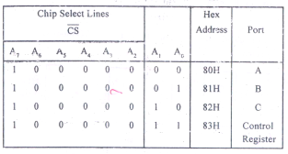

Group A and Group B control:
- Group A and B get the Control Signal from CPU and send the command to the individual control blocks.
- Group A send the control signal to port A and Port C (Upper) PC7-PC4.
- Group B send the control signal to port B and Port C (Lower) PC3-PC0.

PORT A:
- This is a 8-bit buffered I/O latch.
- It can be programmed by mode 0 , mode 1, mode 2 .

PORT B:
- This is a 8-bit buffer I/O latch.
- It can be programmed by mode 0 and mode 1.

PORT C:
- The eight bit ports of PORT C can be used as individual bits or be grouped into two 4 bit ports. C_{upper} (C_{u}) and C _{Lower} (C_{L}).The functions of these ports are defined by writing a control word in the control register.

Functions of Pin:

The signal description of 8255 is briefly presented as follows

- It has 24 I/O programmable pins which can be grouped into three 8 bit parallel ports of Port A,
Port B and Port C.
- It is TTL compatible.
PA7-PA0: These are eight port A lines that acts as either latched output or buffered input lines depending upon the control word loaded into the control word register.
PC7-PC4 : Upper nibble of port C lines. They may act as either output latches or input buffers lines. This port also can be used for generation of handshake lines in mode 1 or mode 2.
PC3-PC0 : These are the lower port C lines, other details are the same as PC7-PC4 lines.
PB0-PB7 : These are the eight port B lines which are used as latched output lines or buffered input lines in the same way as port A.
A1-A0: These are the address input lines and are driven by the microprocessor. These address lines A1-A0 are used for addressing any one of the four registers, i.e. three ports and a control word register as given
in table below.
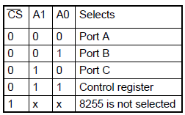

$\overline{\text{RD}}$ : This is the input line driven by the microprocessor and should be low to indicate read operation to 8255.

$\overline{\text{WR}}$: This is an input line driven by the microprocessor. A low on this line indicates write operation.

$\overline{\text{CS}}$: This is a chip select line. If this line goes low, it enables the 8255 to respond to RD and WR signals, otherwise RD and WR signal are neglected • In case of 8086 systems, if the 8255 is to be interfaced with lower order data bus,the A0 and A1 pins of 8255 are connected with A1 and A2 respectively.

D0-D7 : These are the data bus lines those carry data or control word to/from the microprocessor.

RESET: A logic high on this line clears the control word register of 8255. All ports are set as input ports by default after reset.

OPERATING MODES OF 8255
- BSR mode
- I/O mode

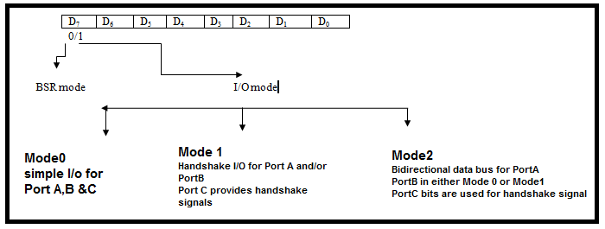

CONTROL WORD FORMATS:

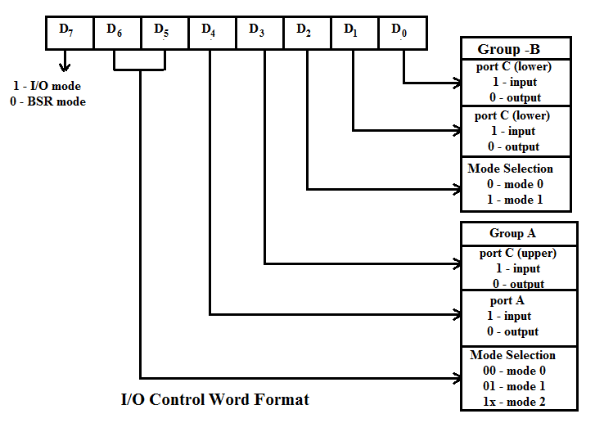

D7 bit of control word decides the type of mode.
- If it is ‘1’. I/O mode is selected.
- If it is ‘0’. BSR mode is selected

a) BSR (BIT SET/RESET) mode:

- The PORT C can be Set or Reset by sending OUT instruction to the CONTROL registers.
- In BSR mode individual bits of Port C can be used for applications such as on/off switch.
- The control word sets or reset one bit at a time.

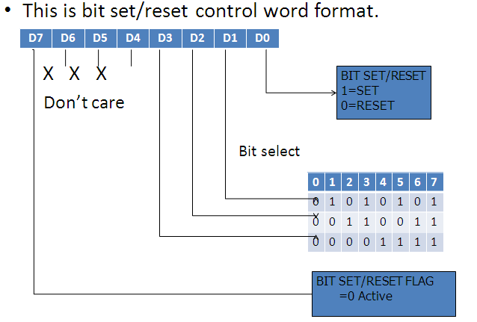

b) FOR I/O MODE

The mode format for I/O as shown in figure

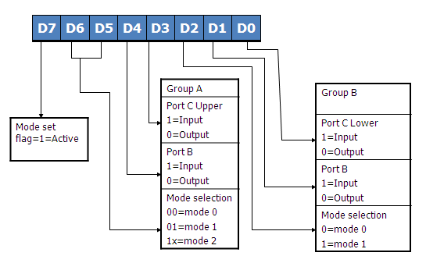

The I/O mode is divided into three modes mode 0, mode 1, and mode 2 given below
- Mode 0 – Basic I/O mode
- Mode 1 – strobbed I/O mode
- Mode 2 – Bidirectional data transfer mode
Steps to communicate with peripherals through the 8255 .They are
1. Determine the addresses of Port A,B and C and of the control register according to the chip select logic and address line A0 and A1.
2. Write a control word in the control register
3. Write I/O instructions to communicate with peripherals through ports A, B and C.control word does not alter any previously transmitted control word with bit D₇=1.Thus the I/O operations of Port A and Port B are not affected by a BSR control word.

I/O MODES:

- MODE 0 (Simple input / Output):
In this mode , port A, port B are used as two simple 8 bit I/O ports and port C as two 4 bit ports used as individually (Simply).
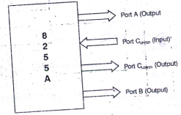
- Features of mode 0 are:
- Any port can be input or output
- Outputs are latched
- Inputs are not latched
2) MODE 1: (Input/output with Hand shake)

In this mode, input or output is transferred by hand shaking Signals. The handshaking signals are exchanged between the microprocessor and peripheral prior to data transfer.

- Features of mode 1

1. Two ports (A and B) function as 8 bit I/O ports .They can be configured either as input or output ports.
2. Each port uses 3 lines from port C as handshake signals. The remaining 2 lines of PORT C can be used for simple I/O operations.

2.1)Input control signal (Mode 1 ):
- STB (Strobe input ) – If this lines falls to logic low level, the data available at 8-bit input port is loaded into input latches.

- IBF (Input buffer full) If this signal rises to logic 1, it indicates that data has been loaded into latches, i.e. it works as an acknowledgement. IBF is set by a low on STB and is reset by the rising edge of RD input.

- INTR (Interrupt request) This active high output signal can be used to interrupt the CPU.
whenever an input device requests the service. INTR is set by a high STB pin and a high at IBF
pin.
- INTE is an internal flag that can be controlled by the bit set/reset mode of either PC₄(INTEA) or PC₂(INTEB) as shown in fig
- INTR is reset by a falling edge of RD input. Thus an external input device can be request the service of the processor by putting the data on the bus and sending the strobe signal.

2.2) Output control signal(Mode 1) :

- OBF (Output buffer full) – This status signal, whenever falls to low, indicates that CPU has written data to the specified output port. The OBF flip-flop will be set by a rising edge of WR signal and reset by a low going edge at the ACK input.
- ACK (Acknowledge input) – ACK signal acts as an acknowledgement to be given by an output device. ACK signal, whenever low, informs the CPU that the data transferred by the CPU to the output device through the port is received by the output device.
- INTR (Interrupt request ) – Thus an output signal that can be used to interrupt the CPU when an output device acknowledges the data received from the CPU.INTR is set when ACK, OBF and INTE are 1. It is reset by a falling edge on WR input. The INTEA and INTEB flags are controlled by the bit set-reset mode of PC6 and PC2 respectively.

- MODE 2 :bi-directional I/O data transfer:

- Features of Mode2

- In this mode, Port A can be configured as the bidirectional port and Port B is either in Mode 0 or Mode 1.
- Port A uses 5 signals from Port C as handshake signals for data transfer .The remaining 3 signals from Port C can be used either as simple I/O or as handshake for Port B.
.

*******************************************************************************
3. Serial Communication Interface (8251)
(Programmable Communication Interface)

Introduction:
The basic concepts concerning the serial I/O mode can be classified into the following categories
1. Interfacing Requirements
2. Alphanumeric codes
3. Transmission format
4. Error checks in data communication
5. Data communication over telephone lines
- Interfacing Requirements

Serial I/O Interfacing
- The MPU selects the peripheral through chip select and uses the control signals .Read to receive data and write to transmit data.
- To communicate with alphabetic letters and decimal numbers of the computer into binary, we use ASCII code of 7 bit 00H to 7FH is assigned to a letter, a decimal number, a symbol or a machine command.
[30 – 39H 0 to 9 ]
[41H– 5AH A to Z]
[21H – 2FH for various symbols]
[00 - 1FH for machine commands]

- Transmission format
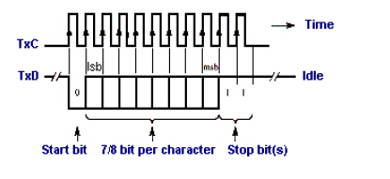
- In synchronous format, receiver and a transmitter are synchronized with the same clock and a block of character is transmitted along with the synchronization information. This format is generally used for high speed transmission (more than 20 Kbits/second)
- The asynchronous format is character oriented. Each character carries the information of the start and stop bits. Transmission starts with one start bit(low) followed by a character , and one or two stop bits (high) .This is also known as framing. It is used in low speed transmission less than 20Kbits/second.
- Communication Modes
According to the direction and simultaneity of data flow, it is classified as
Simplex - Data are transmitted in only one direction.
Example: Transmission from a microcomputer to a printer.
Duplex - Data flow in both direction
- Half Duplex - If the transmission goes one way at a time it is called half duplex.
- Full Duplex – If both transmitting and receiving signals goes simultaneously, it is called full duplex. Example: Transmission between computers.
- Rate of transmission
The rate at which the bits are transmitted is called bits/second or Baud rate. For example 1200 baud = 1200 bits/second. It indicates1200 bits are transmitted in a second. For 1 bit it takes 1/1200 =0.83 ms.
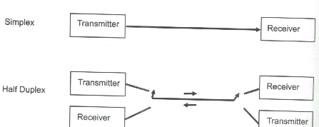
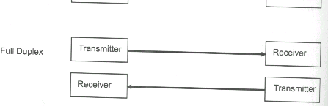

***************************************************************************************
Explain USART (8251) serial communication interface with its functional block diagram.(April 2018)(June 2016)
*************************************************************************************
Programmable Communication Interface 8251 (USART)/ (Programmable serial interface)

Definition:
The 8251 is a programmable USART (Universal Synchronous Asynchronous Receiver Transmitter) is designed for Synchronous and Asynchronous serial communication; The 8251 receives parallel data from the CPU and transmits serial data after conversion. This device also receives serial data from the outside and transmits parallel data to the CPU after conversion.
The block diagram of 8251 includes five sections:
- Read /Write control logic
- Transmitter section
- Receiver Section
- Data bus buffer
- Modem control

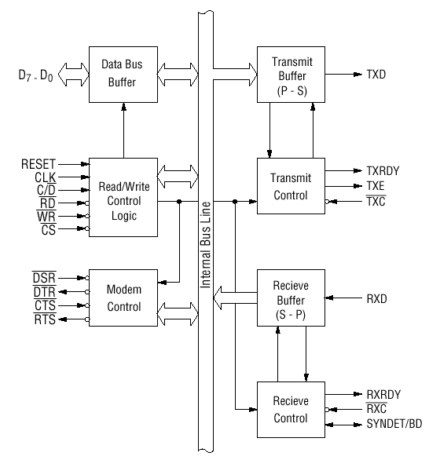
Figure:8251 USART Serial communication Interface

- The control logic interfaces the chip with the MPU determines the functions of the chip
according to the control word in its register and monitors the data flow.

- The transmitter section converts a parallel word received from the MPU into a serial bits and
transmits them over TxD line to a peripheral.

- The receiver section receives serial bits from a peripheral converts them into parallel word and transfers the word to the MPU.

- The MODEM control is used to establish data communication through modems over telephone lines.

1. Transmitter section
- The transmitter accepts parallel data from the MPU and converts them into serial data.
- It has two registers, A buffer register to hold eight bits and an output register to convert eight
bits into a stream of serial bits.
- The MPU writes a byte in the buffer register whenever the output register is empty, the contents of the buffer register are transferred to the output register.
- This section transmits data on the TxD pin with the appropriate framing bits(start & stop).3 output and 1 input signal are associated with transmitter section.

TXD (Transmit Data)
This is an output terminal for transmitting data from which serial-converted data is sent out.

TXRDY (Transmitter Ready)
This is an output terminal during high indicates that the 8251is ready to accept a transmitted data character. It can be used either to interrupt the MPU or to indicate the status.

TXEMPTY (Transmitter Empty)
This signal at logic 1 indicates that the 8251 has transmitted all the characters and the output register is empty. It is reset when a byte is transferred from the buffer to the output register.

TXC (Transmitter clock)
This is a clock input signal which determines the transfer speed of transmitted data. In "synchronous mode," the baud rate will be the same as the frequency of TXC. In "asynchronous mode", it is possible to select the baud rate factor by mode instruction. It can be 1,16 or 64 the baud.

2. Receiver Section

- The receiver accepts serial data on the RxD line from a peripheral and converts them into parallel data.
- The section has two registers, the receiver input register and the buffer register.
- When RxD line goes low, the control logic assumes it is a start bit, waits for half a bit time and samples the line again. If the line is still low, the i/p register accepts the following bits, forms a character and loads it into the buffer register subsequently. The parallel byte is transferred to the Microprocessor when requested.
RXD (Receive Data)
The bits are received serially on this line and converted into a parallel byte in the receiver input register.
RXC (Receiver clock)
This clock signal controls the rate at which bits are received by the USART .In asynchronous mode, the clock can be set to 1,16 and 64 times the baud.

RXRDY (Receiver Ready)
This output signal goes high when USART has a character in the buffer register and is ready to transfer it to the MPU .This line can be used either to indicate the status or to interrupt the MPU.

SYNDET/BD (Input or output terminal)
This is a terminal whose function changes according to mode. In "internal synchronous mode." this terminal is at high level, if sync characters are received and synchronized.

In "asynchronous mode," this is an output terminal which generates "high level" output upon the detection of a "break" character if receiver data contains a "low-level" space between the stop bits of two continuous characters.

3. MODEM Control
.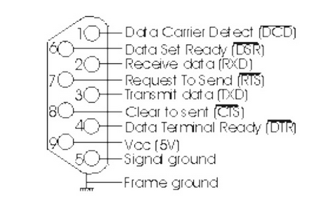
- $\overline{\text{DSR}}$ ( Data set ready)
This is an input port for MODEM interface. This is normally used to check if the Data set is ready
when communicating with a modem.
- $\overline{\text{DTR}}$ ( Data terminal ready)
This is an output port for MODEM interface. It is used to indicate that the device is ready to accept
data when the 8251 is communicating with a modem.
- $\overline{\text{CTS}}$ ( Clear to send)
This is an input terminal for MODEM interface which is used for controlling a transmit circuit. The
terminal controls data transmission if the device is set in "Tx Enable" status by a command. Data is
transmittable if the terminal is at low level.
- $\overline{\text{RTS}}$ ( Request to send data)
This is an output port for MODEM interface. It is used to indicate the MODEM that the receiver is
ready to receive a data byte from the MODEM.

4.Read/Write control logic and Registers
This section includes R/W control logic,
- six input signals,
- control logic and
- 3 buffer registers: Data register, control register and status register.

Control Register
The 16 bit register for a control word consists of two independent bytes. The first byte is called the mode instruction and the second byte is called the command instruction. This register can be accessed as an output port when the C/D pin is high.

Status Register
This input register checks the ready status of a peripheral. This register is addressed as an input port when
the C /D is high .It has the same port address as the control register.

Data Buffer
This bidirectional register can be addressed as an input port and an output port when C/D pin is low.

The input signals to the control logic are as follows.
There are two types of control word.
1. Mode instruction (setting of function)
2. Command (setting of operation)

1) Mode Instruction
Mode instruction is used for setting the function of the 8251. The writing of a control word after resetting will be recognized as a "mode instruction."
8251 Mode word
Items set by mode instruction are as follows:
• Synchronous/asynchronous mode
• Stop bit length (asynchronous mode)
• Character length
• Parity bit
• Baud rate factor (asynchronous mode)
• Internal/external synchronization (synchronous mode)
• Number of synchronous characters (Synchronous mode)
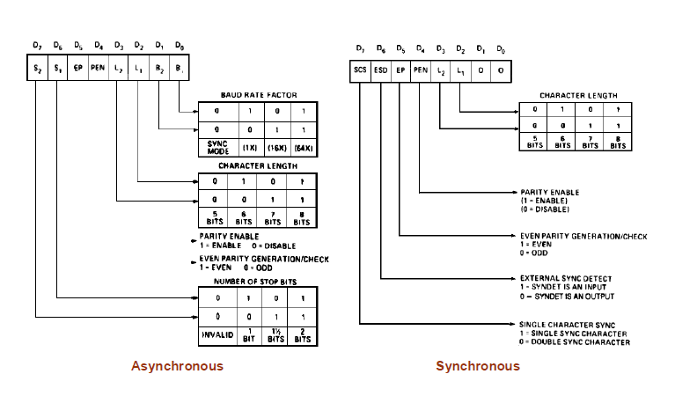

8251 command word
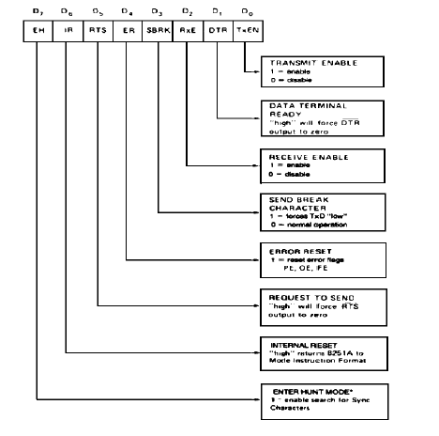
8251 status word

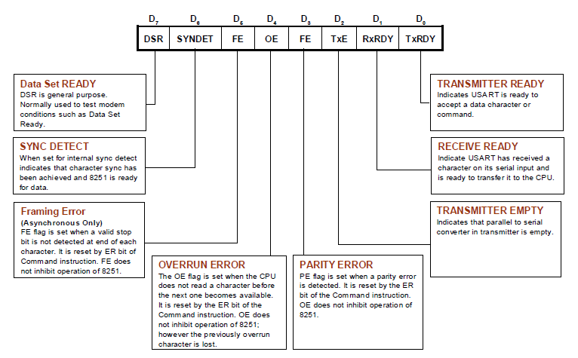

Pin Description
- Initializing the 8251
- To implement serial communication, the MPU must inform 8251 of all details such as mode, baud , stop bits, parity etc.,
- Therefore prior to data transfer ,a set of control words must be loaded into the 16 bit control register of the 8251.The MP must check the readiness of a peripheral by reading the status register.
- The control words are divided into two formats: Mode word and command word.
- The mode word specifies the general characteristics of operation (such as baud, parity, number of stop bits) .The command word enables data transmission and/or reception and the status word provide the information concerning register status and transmission errors.
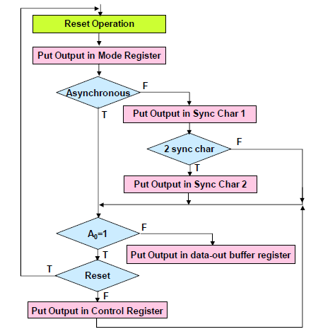

*******************************************************************************
Draw the block diagram of 8279 Keyboard/Display controller and explain how to interface the Hex Key Pad and 7-segment LEDs using 8279. (December 2017)
******************************************************************************

4.Programmable Keyboard/Display controller – 8279

Definition:

A 8279 is a general purpose keyboard display controller that simultaneously drives the display of a system and interferes a keyboard with the CPU, leaving it free for routine task.

- The keyboard is interfaced either in interrupt mode or polled mode.
- In the Interrupt mode, the processor is requested service only if any key is pressed, otherwise
the CPU can proceed with its main task.
- In the Polled mode, the CPU periodically reads an internal flag of 8279 to check for a key pressed.

Basic Description of the 8279
DATA BUS (D7-D0)
All data and commands between the microprocessor and 8279 are transmitted on these lines.
$\overline{\text{RD}}$ (read):
Microprocessor reads the data/ status from 8279.
$\overline{\text{WR}}$ (write):
Microprocessor writes the data to 8279
A0:
A high signal on this line indicates that the word is a command or status. A low signal indicates the data.
RESET:
High signal in this pin resets the 8279. After being reset, the 8279 is placed in the following modes
- 16 x 8 – bit character display – left entry
- Two key lock out
$\overline{\text{CS}}$(Chip Select):
A low signal on this input pin enables the communication between 8279 and the microprocessor.
IRQ (Interrupt Request):
- The interrupt line goes low with each FIFO/sensor RAM reads and returns high if there still information in the RAM
SL₀-SL₃:
- The scan lines which are used to scan the key switch or sensor matrix and the displays digits. These lines can be either encoded (1 of 16) or decoded (1 of 4)

RL₀-RL₇:
- Input return lines which are connected to the scan lines through the keys or sensor switches. They have active internal pull-ups to keep them high serve as an 8- bit input in the strobed input mode.
SHIFT:
- It has an active internal pull-up to keep it high until a switch closure pulls it low.
CNTL/STB:
- For keyboard mode, this line is used as a control input and stored like status on a key closure.
- The line is also the strobed line to enter the data into the FIFO in the strobed input.
OUT A₀ – OUT A₃, OUT B₀ – OUT B₃:
- These two ports are the outputs for the 16x4 display refresh registers. These two ports may also be considered as one 8 – bit port.
- The two 4 – bit ports may be blanked independently.
BD:
This output is used to blank the display digit switching or by a display banking command.
************************************************************************************
Explain the working Principle of 8279 Keyboard/Display Controller.(April 2010)(June 2016) (December 2016)(May 2015)(December 2015)
*************************************************************************************

Keyboard/Display Controller (8279)
A 8279 is a general purpose keyboard display controller that simultaneously drives the display of a system and interferes a keyboard with the CPU, leaving it free for routine task.

Functional block diagram of 8279
It consists of four sections
- Keyboard section
- Scan section
- Display section
- CPU Interface section

CPU INTERFACE SECTION:
- This section has bi-directional data buffer (DB0 –DB7), I/O control lines (RD, WR, CS, A0) and Interrupt Request lines (IRQ).
- The A₀ signal determines whether transmit/receive control word or data is used.
- An active high in line IRQ is generated to interrupt the microprocessor whenever the data is available.

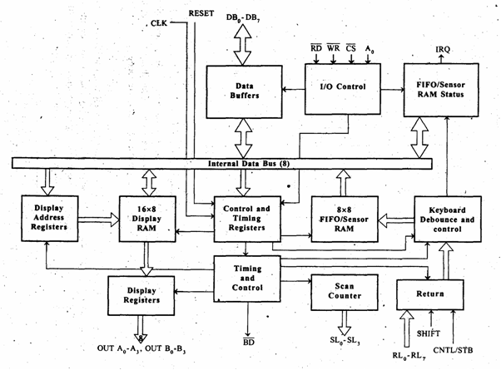
Figure:8279 keyboard /Display Interface

- It consists of
a) A set of four scan lines and eight return lines for interfacing keyboards
b) A set of eight output lines for interfacing display.
A0 | RD | WR | Operation
0 | 0 | 0 | MPU writes the data is 8279
0 | 0 | 1 | MPU reads the data from 8279
1 | 1 | 0 | MPU writes control word to 8279
1 | 0 | 1 | MPU read status word from 8279

KEYBOARD SECTION:
- This section has keyboard debounce and control, 8X8 FIFO/sensor RAM, 8 return lines
(RL0 – RL7) and CNTL/STB and shift lines.
- In the keyboard debounce and control unit, keys are automatically debounced and the keyboard can be operated in two modes.
- Two keys lock out
- N – key roll over
- The 8X8 FIFO/sensor RAM consists of 8 registers that are used to store eight keyboard entries.
- The return lines (RL0-RL7) are connected to eight columns of keyboard.
- The status of shift and CNTL/STB lines are stored along with the key closure.
SCAN SECTION:
- This section has scan counter and four scan lines (SL0 – SL3).
- These lines are decoded by 4 to 16 decoder to generate 16 scan lines.
- Generally SL0 – SL3 are connected with the rows of a matrix keyboard.

DISPLAY SECTION:
- This section has two groups of outputs lines A0 – A3 and B0 – B3. These lines are used to send data to display drivers.
- BD line is used blank the display. It also has 16X8 displays RAM.
- The display address register holds the address of the word currently being written or read by the CPU to or from the display RAM.
- The contents of the registers are automatically updated by 8279 to accept the next data entry by CPU.
Modes of operations of 8279

1. Input (Keyboard) modes
2. Output (Display) modes

- Keyboard modes
- Scanned keyboard mode with N key rollover
In this mode, each key depression is treated independently. When a key is pressed, the debounce circuit waits for 2 keyboards scans and then checks whether the key is still depressed. If it is still depressed, the code is entered in FIFO RAM
- Scanned keyboard mode with 2 key lock out.
It prevents 2 keys from being recognized if pressed simultaneously. If two keys are pressed within
a debounce cycle (simultaneously),no key is recognized till one of them remains
closed, and the other is released. The last key that remains depressed is considered as single valid key depression.

- Display modes

- Left entry mode
The data is entered from the left side of the display unit.

- Right entry mode
The first entry to be displayed is entered on the rightmost display.

Programming the Keyboard Interface :
- Before any keystroke is detected, the 8279 must be programmed
- The first 3 bits of the number sent to the control port (11H) select one of the 8 different control words.

Command Words of 8279

Keyboard Display mode set
The format of the command word is to select different modes of operation of 8279

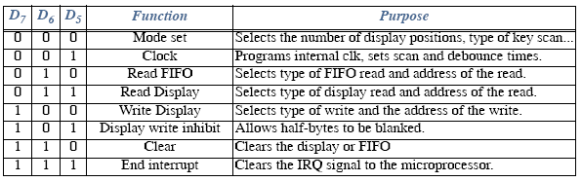

Control Word Description
a)000DDMMM
Mode set: Opcode 000.
DD sets displays mode.
MMM sets keyboard mode
DD field selects either: 8- or 16-digit display Whether new data are entered to the rightmost or leftmost display position.

b) Programmable clock (001PPPPP)
The clock for operation of 8279 is obtained by dividing the external clock input signal by a programmable constant called prescaler.The clock command word programs the internal clock driver.
The code PPPPP, is a prescalar that divides the clock input pin (CLK) to achieve the desired operating frequency, e.g. 100 KHz requires 01010₂

(c)Read FIFO/Sensor RAM(010 AI X AAA )
The read FIFO control word selects the address (AAA) of a keystroke from the FIFO buffer (000 to 111).X - don’t care and AI selects auto-increm(ent for the address

d) Read Display RAM(011 AI AAAA)
This command enables a programmer to read the display RAM data.
The display read control word selects the 4 bit address AAAA points to the 16 byte display RAM positions that is to be read.

e) Write Display RAM(100 AI AAAA)
The display write control word selects the 4 bit address AAAA points to the 16 byte display RAM positions that is to be written.. Display. Z selects auto-increment so subsequent writes go to subsequent display positions.

f) Display with inhibit blanking (1010WWBB)
The display write inhibit control word inhibits writing to either the leftmost 4 bits of the display (left W) or rightmost 4 bits (right W).BB works similarly except that they blank (turn off) half of the output pins.

g) Clear Display RAM (1100CCFA)
The clear control word clears the display, FIFO or both Bit F clears FIFO and the display RAM status, and sets address pointer to 000.
If CC are 00 or 01, all display RAM locations become 00000000.
If CC is 10, --> 00100000, if CC is 11, --> 11111111.
h) End Interrupt/Error mode set(1110E000 )
End of Interrupt control word is issued to clear IRQ pin to zero in sensor matrix mode
- Clock must be programmed first. If 3.0 MHz drives CLK input, PPPPP is programmed to 30 or 11110₂.
- Keyboard type is programmed next. The previous example illustrates an encoded keyboard, external decoder used to drive matrix.
- Program the operation of the FIFO.Once programmed never reprogrammed done, until a procedure is needed to read prior keyboard codes .

**************************************************************************************
Draw and explain the functional block diagram of 8254 Timer and its command word format.[ May/June 2016, Nov/Dec 2016, May/June 2013, May/June 2009][Dec 2017]
Explain the blocks diagram and modes of the 8254 timer. {Nov/Dec 2015 .Dec 2012,June 2014]
*************************************************************************************
5. Programmable Interval Timer (8254/8253)

Definition:

The 8254 is a programmable interval timer/counter is used for the generation of accurate time delays , controlling real-time events such as real-time clock, events counter, and motor speed and direction control under software control.
After the desired delay, the 8254 will interrupt the CPU. This makes microprocessor to be free the tasks related to the counting process and can execute the programs in memory, while the timer device may perform the counting tasks. This minimizes the Software overhead on the microprocessor.

Application of 8254:
- Real time clock
- Event-counter
- Digital one-shot
- Programmable rate generator
- Square wave generator
- Binary rate multiplier
- Complex waveform generator
- Complex motor controller

It consists of
- Three independent 16-bit programmable counters (timers)
- a data bus buffer
- Read/Write control Logic
- Control register

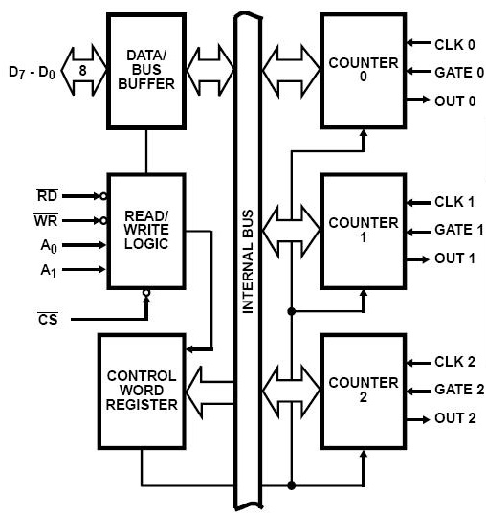
8254 Functional Block diagram of 8253

DATA BUS BUFFER:
This 3- state, bi-directional, 8-bit buffer is used to interface the 8254 to the system bus.
READ/WRITE LOGIC:
- The Read/Write logic accepts inputs from the system bus and generates control signals for the other functional blocks of the 8254.
- A1 and A0 select one of the three contents counters or the control word register to be read from/written into.
- A “low” on the RD input tells the 8254 that the CPU is reading one of the counters.
- A “low” on the WR input tells the 8254 that the CPU is writing either a control word or an initial count.
- Both RD and WR are qualified by CS; RD and WR are ignored unless than 8254 has been selected by holding CS low.
CONTROL WORD REGISTER:
- The control word register is selected by the read/write logic when A1, A0=11.
- If the CPU then does a write operation to the 8254, the data is stored in the control word register and is interpreted as a control word used to define the operation of the counters.
- The control word register can only be written to; status information is available with the Read-Back command.
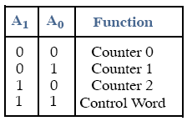
COUNTER 0, COUNTER 1, COUNTER 2:
- Each is a 16 bit down counter
- The counters are fully independent. Each counter may operate in a different mode.
- Each counter has a separate clock input, count enable (gate) input lines and output lines.
- The control word register is not a part of the counter itself, but its contents determine how the counter operates.

8254 Pin Description
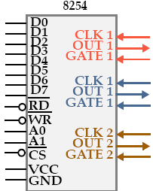
D₀ to D_{7 :} read, write, Chip select & Address pins A1 and A0 are connected to Microprocessor
A₁, A₀ The address inputs select one of the four internal registers for programming, reading, or writing to a counter.
CLK: The clock input is the timing source for each of the internal counters. It is often connected to the PCLK signal from the bus controller
CS: Chip Select enables the 8254 for programming, and reading and writing
Gate: The gate input controls the operation of the counter in some modes
OUT: A counter output is where the wave-form generated by the timer is available
Read/Write causes data to be read/written from the 8254 and often connects to the
Each counter is individually programmed by writing a control word, followed by the initial count.The control word allows the programmer to select the counter, model of operation, binary or BCD count and type of operation (read/write).
Command word of 8254
Each counter may be programmed with a count of 1 to FFFFH. Minimum count is 1 all modes except 2 and 3 with minimum count of 2.
Each counter has a program control word used to select the way the counter operates.
If two bytes are programmed, then the first byte (LSB) stops the count, and the second byte (MSB) starts the counter with the new count.
****************************************************************************************
Explain the various modes of operation of timer interface 8253/8254.[Dec 2013,Dec 2015,Dec 2016]
**************************************************************************************
There are 6 modes of operation for each counter
- MODE 0: INTERRUPT ON TERMINAL COUNT :
- MODE 1: Programmable One-Shot:
- MODE 2: RATE GENERATOR:
- MODE 3: SQUARE WAVE GENERATOR
- MODE 4: SOFTWARE TRIGGERED STROBE :
- MODE 5: HARDWARE TRIGGERED STROBE (RETRIGGERABLE):

Modes of operation

MODE 0: INTERRUPT ON TERMINAL COUNT:
- Mode 0 is typically used for event counting. After the Control Word is written, OUT is initially low, and will remain low until the Counter reaches zero.
- OUT then goes high and remains high until a new count or a new Mode 0 Control Word is written into the Counter.
- GATE = 1 enables counting; GATE = 0 disables counting. GATE has no effect on OUT.
- The output becomes a logic 0 when the control word is written and remains there until N plus the number of programmed counts.
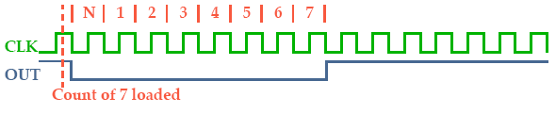
MODE 1: PROGRAMMABLE ONE-SHOT:
- OUT will be initially high.
- OUT will go low on the CLK pulse following a trigger to begin the one-shot pulse, and will remain low until the Counter reaches zero.
- OUT will then go high and remain high until the CLK pulse after the next trigger.
- The Gate input triggers the counter to output a 0 pulse for count clocks. Counter reloaded if Gate is pulsed again.
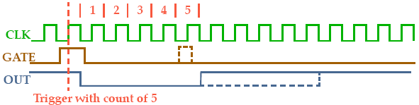
MODE 2: RATE GENERATOR:
- This Mode functions like a divide-by-N counter. It is typically used to generate a Real Time Clock interrupt.
- OUT will initially be high. When the initial count has decremented to 1, OUT goes low for one CLK pulse. OUT then goes high again, the Counter reloads the initial count and the process is repeated.
- Mode 2 is periodic, the same sequence is repeated indefinitely. For an initial count of N, the sequence repeats every N CLK cycles.
- GATE = 1 enables counting; GATE = 0 disables counting. If GATE goes low during an output pulse, OUT is set high immediately.
- Counter generates a series of pulses 1 clock pulse wide. The separation between pulses is determined by the count. The cycle is repeated until reprogrammed or G pin set to 0.

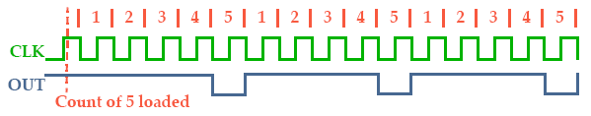
MODE 3: SQUARE WAVE GENERATOR
- Mode 3 is typically used for Baud rate generation. Mode 3 is similar to Mode 2 except for the duty cycle of OUT. OUT will initially be high.
- When half the initial count has expired, OUT goes low for the remainder of the count. Mode 3 is periodic; the sequence above is repeated indefinitely.
- An initial count of N results in a square wave with a period of N CLK cycles.GATE = 1 enables counting; GATE = 0 disables counting. If GATE goes low.while OUT is low, OUT is set high immediately; no CLK pulse is required.
- Even counts: OUT is initially high. The initial count is loaded on one CLK pulse and then is decremented by two on succeeding CLK pulses.
- When the count expires OUT changes value and the Counter is reloaded with the initial count. The above process is repeated indefinitely.so for odd counts, OUT will be high for (N + 1)/2 counts and low for (N - 1)/2 counts
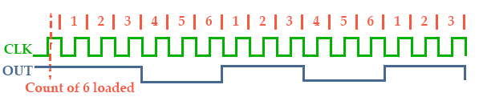
MODE 4: SOFTWARE TRIGGERED STROBE :
• OUT will be initially high. When the initial count expires, OUT will go low for one CLK pulse and then go high again. The counting sequence is ``triggered'‘ by writing the initial count. (G must be 1).
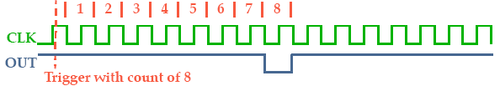
MODE 5: HARDWARE TRIGGERED STROBE (RETRIGGERABLE):

OUT will initially be high. Counting is triggered by a rising edge of GATE. When the initial count has expired, OUT will go low for one CLK pulse and then go high again. G controls similar to Mode 1.
Trigger with count of 5
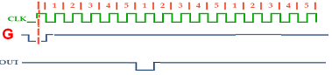

*******************************************************************************
Explain the working principle of 8257 DMA controller interface. (June 2016)
What is DMA? Explain the DMA based data transfer sing DMA controller (April 2015) *******************************************************************************
6. Direct Memory Access
Direct memory access (DMA) or DMA mode of data transfer is the fastest amongst all the modes of data transfer. In this mode, the device may transfer data directly to/from memory without any interference from the CPU.
DMA Controller
The DMA controller (8257) allows certain hardware subsystems to read/write data to/from memory without microprocessor intervention, allowing the processor to do other work.
.

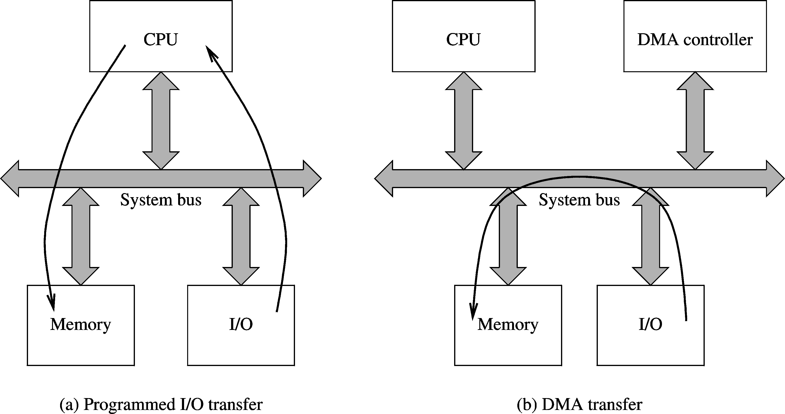

It is used in disk controllers, video/sound cards etc, or between memory locations. Typically, the CPU initiates DMA transfer, does other operations while the transfer is in progress, and receives an interrupt from the DMA controller once the operation is complete.

It contains of five main blocks.

- Data bus buffer
- Read/Control logic
- Control logic block
- Priority resolver
- DMA channels.

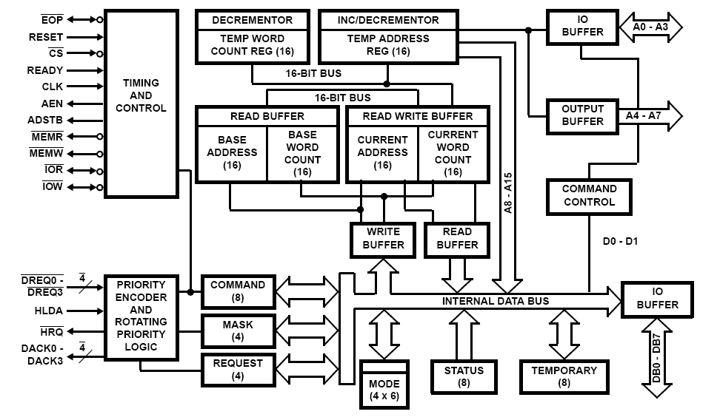
Figure:8237 DMA controller

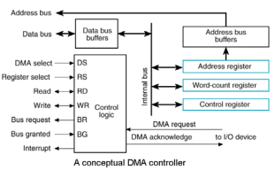

- Programming the 8237
There are 4 steps required to program the address and count registers first:
1. Clear the F/L flip-flop with a clear F/L command
2. Disable the channel
3. Program the LSB and then MSB of the address
4. Program the LSB and then MSB of the count
Additional programming is required to select the mode of operation before the channel is enabled and started.

Internal registers
- The current address register (CAR) is used to hold the 16-bit memory address used for the DMA transfer.
- The current word count register (CWCR) programs a channel for the number of bytes (up to 64K) transferred during a DMA action.
- The base address (BA) and base word count (BWC) registers are used when auto-initialization
- is selected for a channel. In this mode, their contents will be reloaded to the CAR and CWCR after the DMA action is completed.
- Each channel has its own CAR, CWCR, BA and BWC.
- The command register (CR) programs the operation of the 8237 DMA controller
- The mode register (MR) programs the mode of operation for a channel.
- The request register (RR) is used to request a DMA transfer via software, which is very useful in memory-to-memory transfers.
- The mask register set/reset (MRSR) sets or clears the channel mask to disable or enable particular DMA channels.
- The status register shows the status of each DMA channel.

Data bus buffer:
- It is a tri-state, bidirectional, 8 bit buffer which interfaces the 8257 to the system data in the slave mode; it is used to transfer data between microprocessor and internal registers.
- In master mode, it is used to send higher byte address (A8-A15) on the data bus.
Read/write logic:
- When the microprocessor is programming or reading one of the internal registers of the read/write logic accepts the I/O read (IOR) or low signal.
- Decodes least significant four address bits (A0-A7) and either writes the contents of the data bus addressed register or places the contents of the addressed register onto data bus.
- During DMA cycles the Read/write logic generates the I/O read and memory write or I/O write and memory read signals IOR control the data transfer between peripheral and memory device.

DMA channels:
The 8257 provides four identical channels labeled CH₀, CH₁, CH₂ and CH₃. Each channel has two-16 bit registers. They are
1. DMA address register
2. Terminal count register
1. DMA address register:
- It specifies the address of the first memory location to be accessed.
- It is necessary to load valid memory address in the DMA address register before channel is enabled.
2. Terminal count register:
- The value loaded into the low order 14 bits of TCR specifies the number of DMA cycles minus one (N-1) before TC output is activated.
- Therefore, for N number of desired DMA cycles it is necessary to load the value N-1 into the low order 14 bits of TCR.
- MSB 2 bits specify the type of operation to be performed.
Control Logic:
- It controls the sequence of operations during all DMA cycles by generating the appropriate control signals and the 16 bit address that specified the memory location to be accessed.
- It consists of mode set register and status register.
- Mode set register is programmed by the CPU to configure 8257 whereas the status register is read by CPU to check which channels have reached a terminal count condition and status of update flag.

- Mode set register:
- LSB 4 bits are the enable 4 DMA channels.
- MSB 4 bits are the enable auto load, TC stop, extended write, rotating priority modes and terminal count registers.
- It is cleared by RESET input, this disabling all options, inhibiting all channels and preventing bus conflicts on power-up.
Master mode,
- It controls the sequence of DMA operation during all DMA cycles.
- It generates address and control signals.
- It increments 16 bit address and decrement 14 bit counter registers.
- It activates a HRQ signal on DMA channel Request.
Slave mode it is disabled.

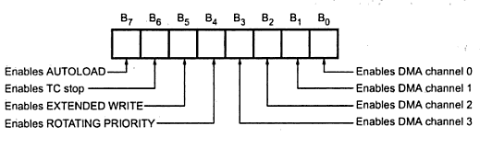
- STATUS REGISTER:
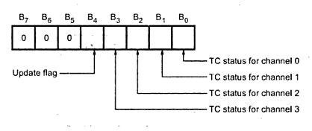
- It indicates which channels have reached a terminal count condition and includes the update flag.
- The Tc status bit=1, terminal count has been reached for that channel.
- Tc bit remains set until the status register is read or the 8257 is reset.
- Update flag =1, 8257 is executing update cycle
- In update cycle 8257 lad parameters in channel 3 to channel 2.

PRIORITY RESOLVER:
It resolves the peripherals request. It can be programmed to work into two modes, either fixed mode or rotating priority mode.

Initializing of DMA controller

- A DMA controller is capable of becoming the bus master and supervising a transfer between an I/O or mass storage interface and memory. While making a transfer, it must be able to place memory address on the bus and send and receive handshaking signals in a manner similar to that of the bus control logic. The purpose of a DMA controller is to perform a sequence of transfers (ie a block transfer) by stealing bus cycles.

- A DMA controller is designed to service one or more I/O mass storage interfaces, and each interface is connected to the controller by a set of conductors. A portion of a DMA controller for servicing a single interface is called a channel..

- The general organization of a one channel DMA controller and its principal connection is shown in figure. In addition to the usual control and status registers, each channel must contain an address register and a byte (or word) count register.

- Initializing the controller consists of filling these registers with the beginning (or ending) address of the memory array that is to be used as a buffer and the number of bytes (words) to be transferred .For an input to memory, each time the interface has data to transfer it makes a DMA request

- The controller then makes a bus request and when it receives a bus grant, it puts the contents of the address register on the address bus, sends an acknowledgement back to the interface, and issues I/O read and memory write signals. The interface then puts the data on the data bus and drops its request.

- When the memory accepts the data it returns a ready signal to the controller, which then increments (or decrements) the address register, decrements the byte (word) count, and drops its bus request.

- Upon the count reaching zero, the process stops and a signal is sent to the processor as an interrupt request or to the interface to notify it that the transfers have terminated. An output is similarly executed except that the controller issues I/O write and memory read signals and the data are transferred in the other direction.

DRQ0-DRQ3 (DMA Request):
These are the asynchronous peripheral request input signal. The request signals is generated by external peripheral device.
DACK0-DACK3:
These are the active low DMA acknowledge output lines. Low level indicate that, peripheral is selected for giving the information (DMA cycle).In master mode it is used for chip select
HLDA becomes active to indicate the processor has placed its buses at high-impedance state as can be seen in the timing diagram,there are a few clock cycles between the time that HOLD changes and until HLDA changes
HLDA output is a signal to the requesting device that the processor has relinquished control of its memory and I/O space. one could call HOLD input a DMA request input and HLDA output a DMA grant signal
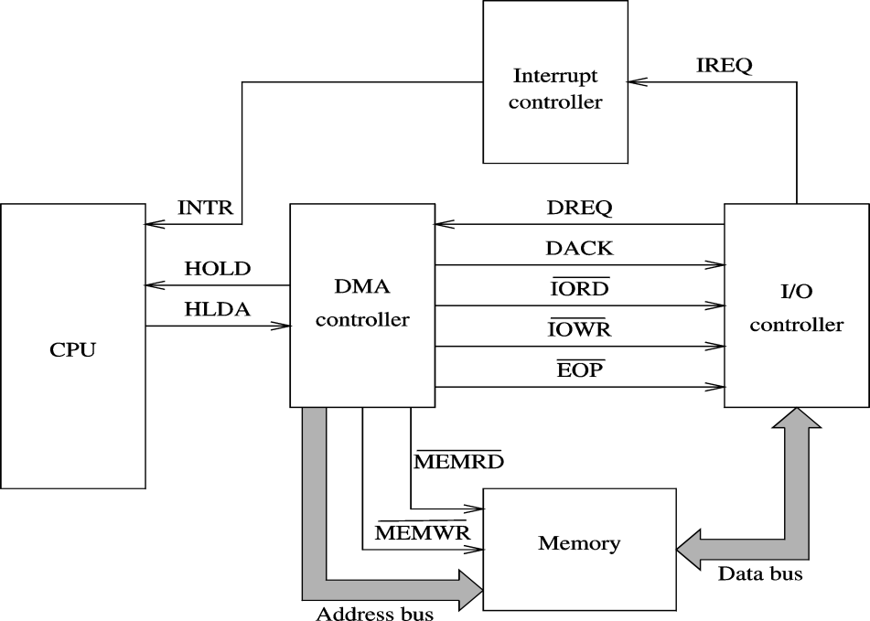
Steps in a DMA operation
- Processor initiates the DMA controller gives device number, memory buffer pointer, called channel initialization.
- Once initialized, it is ready for data transfer.
- When ready, I/O device informs the DMA controller .DMA controller starts the data transfer process
- Obtains bus by going through bus arbitration
- Places memory address and appropriate control signals
- Completes transfer and releases the bus
- Updates memory address and count value
- If more to read, loops back to repeat the process
Notify the processor when done typically uses an interrupt

Modes of DMA operation

Each channel may be put in one of four modes,with its current mode being determined by bits 7 and6 of the channel’s mode register .The four possible modes are

a) Byte b) Burst c) Block
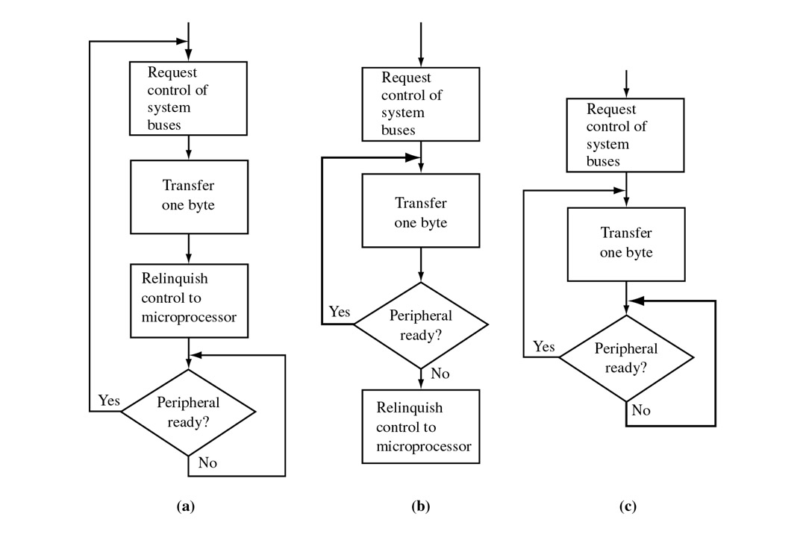
- Single transfer mode (01)
After each transfer the controller will release the bus to the processor for at least one bs cycle, but will immediately begin testing for DREQ inputs and proceed to steal another cycle as soon as a DREQ line becomes active.
- Block transfer mode (10)
DREQ need only be active until DACK becomes active,after which the bus is not released until the entire block of data has been transferred.
- Demand Transfer mode(00)
This is similar to the block mode except that DREQ is tested after each transfer. If DREQ is inactive , transfers are suspended until DREQ once again becomes active ,at which time the block transfer continues from the point at which it was suspended. This allows the interface to stop the transfer in the event that its device cannot keep up.
- Cascade Mode(11)
In this mode 8237s may be cascaded so that more than four channels can be included in the DMA subsystem. In cascading the controllers ,those in the second level are connected to those in the first level by joining HRQ to DREQ and HLDA to DACK ,To conserve space, this mode will not be considered further.
In this mode
Single-cycle mode: DMA data transfer is done one byte at a time
Burst-mode: DMA transfer is finished when all data has been moved.

***************************************************************************************
Draw the block diagram of 8259A and explain how to program 8259A (April 2010).(Dec 2018)
Explain the working of 8259 with a neat block diagram . (Nov/Dec 2016/April 2015)
**********************************************************************************

7. Programmable Interrupt controller (8259)

Definition:

- The Intel 8259 Programmable Interrupt Controller handles up to eight vectored priority interrupts or the CPU.It is cascadable for up to 64 vectored priority interrupts without additional circuitry. It is packaged in a 28-pin DIP, uses NMOS technology and requires a single a5V supply.

- It accepts requests from the peripheral equipment, determines which of the incoming requests is of the highest importance (priority), ascertains whether the incoming request has a higher priority value than the level currently being serviced, and issues an interrupt to the CPU based on this determination.

- Interrupt Request Register (RR): IRR stores all the interrupt request in it in order to serve them one by one on the priority basis.
- In-Service Register (ISR): This stores all the interrupt requests those are being served, i.e. ISR keeps a track of the requests being served.
- Priority Resolver: This unit determines the priorities of the interrupt requests appearing simultaneously. The highest priority is selected and stored into the corresponding bit of ISR during INTA pulse. The IR0 has the highest priority while the IR7 has the lowest one, normally in fixed priority mode. The priorities however may be altered by programming the 8259A in rotating priority mode.
- Interrupt Mask Register (IMR) : This register stores the bits required to mask the interrupt inputs. IMR operates on IRR at the direction of the Priority Resolver.
Interrupt Control Logic: This block manages the interrupt and interrupt acknowledge signals to
be sent to the CPU for serving one of the eight interrupt requests. This also accepts the interrupt acknowledge (INTA) signal from CPU that causes the 8259A to release vector address on to the data bus.
- Data Bus Buffer: This tristate bidirectional buffer interfaces internal 8259A bus to the microprocessor system data bus. Control words, status and vector information pass through data buffer during read or write operations.
- Read/Write Control Logic: This circuit accepts and decodes commands from the CPU. This block also allows the status of the 8259A to be transferred on to the data bus.
- Cascade Buffer/Comparator: This block stores and compares the ID’s all the 8259A used in system. The three I/O pins CASO-2 are outputs when the 8259A is used as a master. The same pins act as inputs when the 8259A is in slave mode. The 8259A in master mode sends the ID of the interrupting slave device on these lines. The slave thus selected, will send its preprogrammed vector address on the data bus during the next INTA pulse.
- CS: This is an active-low chip select signal for enabling RD and WR operations of 8259A. INTA function is independent of CS.
- WR: This pin is an active-low write enable input to 8259A. This enables it to accept command words from CPU.
- RD: This is an active-low read enable input to 8259A. A low on this line enables 8259A to release status onto the data bus of CPU.
- D0-D7 : These pins from a bidirectional data bus that carries 8-bit data either to control word or from status word registers. This also carries interrupt vector information.
- CAS0 – CAS2 Cascade Lines: A signal 8259A provides eight vectored interrupts. If more interrupts are required, the 8259A is used in cascade mode. In cascade mode, a master 8259A along with eight slaves 8259A can provide up to 64 vectored interrupt lines. These three lines act as select lines for addressing the slave 8259A.
- PS/EN: This pin is a dual purpose pin. When the chip is used in buffered mode, it can be used as buffered enable to control buffer transreceivers. If this is not used in buffered mode then the pin is used as input to designate whether the chip is used as a master (SP =1) or slave (SP = 0).
- INT: This pin goes high whenever a valid interrupt request is asserted. This is used to interrupt the CPU and is connected to the interrupt input of CPU.
- IR0 – IR7 (Interrupt requests) :These pins act as inputs to accept interrupt request to the CPU. In edge triggered mode, an interrupt service is requested by raising an IR pin from a low to a high state and holding it high until it is acknowledged, and just by latching it to high level, if used in level triggered mode.
- A0 : This input signal is used in conjunction with WR and RD signals to write commands into the various command registers, as well as reading the various status registers of the chip. This line can be tied directly to one of the address lines.

Command Words of 8259A

The 8259A accepts two types of command words generated by the CPU:

1. Initialization Command Words (ICWs):
Before normal operation can begin, each 8259A in the system must be brought to a starting pointed by a sequence of 2 to 4 bytes timed by WR pulses.

2. Operational Command Words (OCWs):
These are the command words which command the 8259A to operate in various interrupt modes.
These modes are:
a. Fully nested mode
b. Rotating priority mode
c. Special mask mode
d. Polled mode
The OCWs can be written into the 8259A anytime after initialization.

- Interrupt Sequence of 8259 Programmable Interrupt Controller

Interrupt Sequence with an 8085 system

1. One or more IR lines are raised high that set corresponding IRR bits.
2. 8259A resolves priority and sends an INT signal to CPU.
3. The CPU acknowledge with INTA pulse.
4. Upon receiving an INTA signal from the CPU, the highest priority ISR bit is set and the corresponding IRR bit is reset. The 8259 will also release a CALL instruction code (11001101) on to the 8 bit data through its D7 - D0 pins.
5. The CALL instruction will initiate a second INTA pulse. During this period 8259A releases an 8-bit pointer on to a data bus from two more INTA pulses to be sent to the 8259 from the CPU group.
6. These two INTA pulses allow the 8259 to release its programmed subroutine address onto the data bits. The lower 8 bit address is released at the first INTA pulse and the higher 8 bit address is released at the second INTA pulse.
7. This completes the 3 byte CALL instruction released by the 8259. Interrupt cycle. The ISR bit is reset at the end of the second INTA pulse if automatic end of interrupt (AEOI) mode is programmed. Otherwise ISR bit remains set until an appropriate EOI command is issued at the end of interrupt subroutine.

- Priority Modes

1.Fully Nested Mode

- IR0 is the highest and IR7 is the lowest one
- In addition any IR can be assigned the highest priority; the priority sequence will begin at that IR.

Example:

IR0 | IR1 | IR2 | IR3 | IR4 | IR5 | IR6 | IR7
4 | 5 | 6 | 7 | 0 | 1 | 2 | 3

2.Automatic Rotation(equal Priority):
In this mode, a device which one is being serviced will be considered as a lowest priority in the next time
First  Time | IR0 | IR1 | IR2 | IR3 | IR4 | IR5 | IR6 | IR7
First  Time | 6 | 7 | 0 | 1 | 2 | 3 | 4 | 5
Second Time | IR0 | IR1 | IR2 | IR3 | IR4 | IR5 | IR6 | IR7
Second Time | 1 | 0 | 7 | 6 | 5 | 4 | 3 | 2

3.Specific rotation mode(Specific Priority)
The programmer can change the priorities by programming the bottom priority and ths fixing all other priorities.ie if IR4 is programmed as the lowest priority ,then IR% will have the highest one.

End of Interrupt (EOI)
- After the completion of an interrupt service, the corresponding ISR bit needs to be reset.
- This is called the End of Interrupt (EOI).
- It can be issued in 3 formats. They are,

- Non-specific EOI command→When the 8259 receives this command, it resets the

highest priority ISR bit.
- Specific EOI command→ It specifies which ISR bit to be reset.
- Automatic EOI command→ When the 8259 receives the third signal, the ISR bit is reset

Command and Status Words of 8259

  - Command Word for Operational Command Words (OCWs)
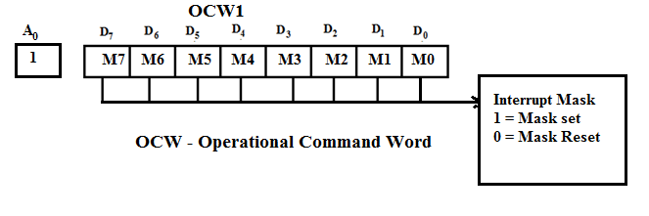

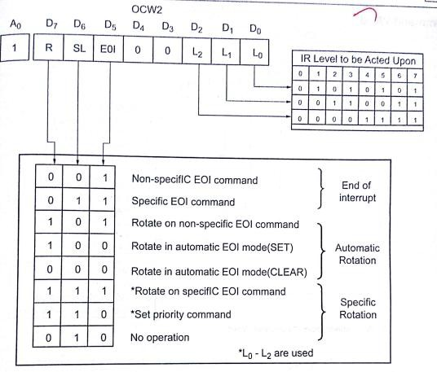

****************************************************************************************
Explain A/D interface with 8085 with neat sketch.(Dec 2014)
Explain how D/A and A/D interfacing done with 8085with an application(April 2015)(Dec 2017)
***************************************************************************************
8.Analog to digital conversion
- The process of analog to digital conversion is a slow process, and the microprocessor has to wait for the digital data till the conversion is over.
- After the conversion is over, the ADC sends end of conversion EOC signal to inform the microprocessor that the conversion is over and the result is ready at the output buffer of the ADC. These tasks of issuing an SOC pulse to ADC, reading EOC signal from the ADC and reading the digital output of the ADC are carried out by the CPU using 8255 I/O ports.
- The time taken by the ADC from the active edge of SOC pulse till the active edge of EOC signal is called as the conversion delay of the ADC.
- It may range anywhere from a few microseconds in case of fast ADC to even a few hundred milliseconds in case of slow ADCs.
- The available ADC in the market use different conversion techniques for conversion of analog signal to digitals. Successive approximation techniques and dual slope integration techniques are the most popular techniques used in the integrated ADC chip.

General algorithm for ADC interfacing contains the following steps:
1. Ensure the stability of analog input, applied to the ADC.
2. Issue start of conversion (SOC) pulse to ADC
3. Read end of conversion signal to mark the end of conversion processes.
4. Read digital data output of the ADC as equivalent digital output. 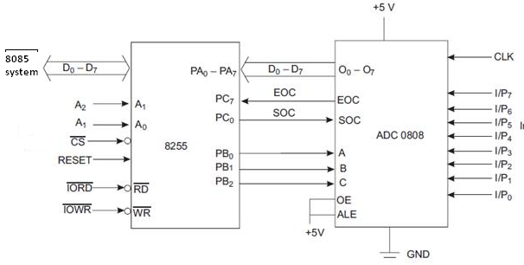
Figure:ADC0808 interfacing with 8085 using 8255

- Analog input voltage must be constant at the input of the ADC right from the start of conversion till the end of the conversion to get correct results.
- This may be ensured by a sample and hold circuit which samples the analog signal and holds it constant for a specific time duration.
- The microprocessor may issue a hold signal to the sample and hold circuit. If the applied input changes before the complete conversion process is over, the digital equivalent of the analog input calculated by the ADC may not be correct.

ADC 0808/0809 :
- The analog to digital converter chips 0808 and 0809 are 8-bit CMOS, successive approximation converters.

- This technique is one of the fast techniques for analog to digital conversion. The conversion delay is 100μs at a clock frequency of 640 KHz, which is quite low as compared to other converters.

- These converters do not need any external zero or full scale adjustments as they are already taken care of by internal circuits. These converters internally have a 3:8 analog multiplexer so that at a time eight different analog conversion by using address lines ADD A, ADD B, ADD C.

- Using these address inputs, multichannel data acquisition system can be designed using a single ADC.

- The CPU may drive these lines using output port lines in case of multichannel applications. In case of single input applications, these may be hardwired to select the proper input.

- There are unipolar analog to digital converters, i.e. they are able to convert only positive analog input voltage to their digital equivalent.

- These chips do not contain any internal sample and hold circuit.If one needs a sample and hold circuit for the conversion of fast signal into equivalent digital quantities, it has to be externally connected at each of the analog inputs.
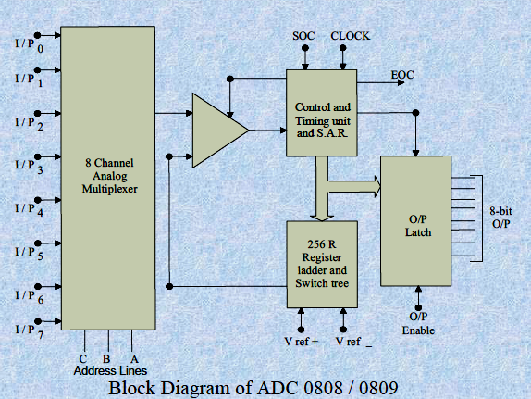
• Vcc Supply pins +5V
• GND GND
• Vref + Reference voltage positive +5 Volts maximum.
• Vref_ Reference voltage negative 0Volts minimum
I/P0–I/P7 Analog inputs
• ADD A,B,C Address lines for selecting analog inputs.
• O7 – O0 Digital 8-bit output with O7 MSB and O0 LSB
• SOC Start of conversion signal pin
• EOC End of conversion signal pin
• OE Output latch enable pin, if high enables output
• CLK Clock input for ADC

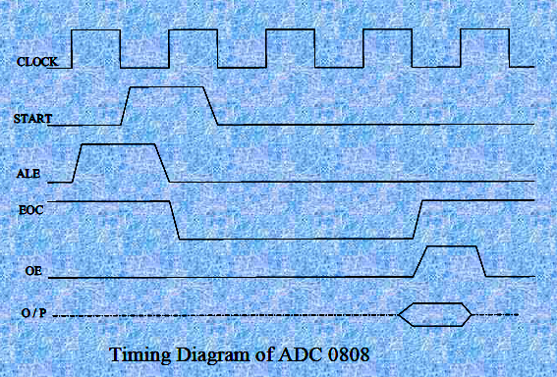

Example: Interfacing ADC 0808 with 8085using 8255 ports. Use port A of 8255 for transferring digital data output of ADC to the CPU and port C for control signals.Assume that an analog input is present at I/P2 of the ADC and a clock input of suitable frequency is available for ADC.

• Solution: The analog input I/P2 is used and therefore address pins A,B,C should be 0,1,0 respectively to select I/P2. The OE and ALE pins are already kept at +5V to select the ADC and enable the outputs. Port C upper acts as the input port to receive the EOC signal while port C lower acts as the output port to send SOC to the ADC.
Port A acts as a 8-bit input data port to receive the digital data output from the ADC. The 8255 control word is written as follows:
D₇ D₆ D₅ D₄ D₃ D₂ D₁ D₀
1 0 0 1 1 0 0 0

The required ALP is as follows:
MOV A, 98h ; initialise 8255 as
OUT CWR, ;discussed above.
MOV A, 02h ; Select I/P2 as analog
OUT Port B , input.
MOV AL, 00h ; Give start of conversion
OUT Port C ; pulse to the ADC
MOV AL, 01h
OUT Port C
MOV AL, 00h
OUT Port C
WAIT: IN Port C ;Check for EOC by
RCR ; reading port C upper and
JNC WAIT ; rotating through carry.
IN Port A ; If EOC, read digital equivalent ;in AL
HLT ; Stop

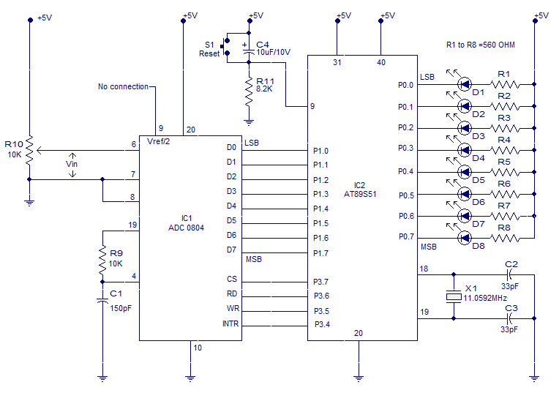

Figure:Interfacing ADC to 8051
The circuit initiates the ADC to convert a given analogue input , then accepts the corresponding digital data and displays it on the LED array connected at P0
ORG 00H
MOV P1,#11111111B // initiates P1 as the input port
MAIN: CLR P3.7 // makes CS=0
SETB P3.6 // makes RD high
CLR P3.5 // makes WR low
SETB P3.5 // low to high pulse to WR for starting conversion
WAIT:JB P3.4,WAIT // polls until INTR=0
CLR P3.7 // ensures CS=0
CLR P3.6 // high to low pulse to RD for reading the data from ADC
MOV A,P1 // moves the digital data to accumulator
CPL A // complements the digital data
MOV P0,A // outputs the data to P0 for the LEDs
SJMP MAIN // jumps back to the MAIN program
END
***************************************************************************
Explain the interfacing of D/A converter with 8085 and 8051.and Write a program for generating any typical waveform.(June 2016)(Dec 2018)
***************************************************************************

9.Interfacing Digital To Analog Converters

- The digital to analog converters convert binary number into their equivalent voltages. The DAC find applications in areas like digitally controlled gains, motors speed controls, programmable gain amplifiers etc.
- AD 7523 8-bit Multiplying DAC : This is a 16 pin DIP, multiplying digital to analog converter, containing R-2R ladder for D-A conversion along with single pole double thrown NMOS switches to connect the digital inputs to the ladder.
- The pin diagram of AD7523 is shown in fig the supply range is from +5V to +15V, while V_{ref} may be anywhere between -10V to +10V. The maximum analog output voltage will be anywhere between -10V to +10V, when all the digital inputs are at logic high state.
- Usually a zener is connected between OUT1 and OUT2 to save the DAC from negative transients. An operational amplifier is used as a current to voltage converter at the output of AD to convert the current output of AD to a proportional output voltage.
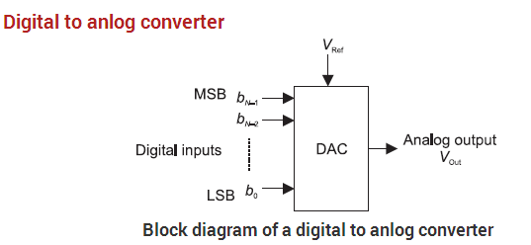

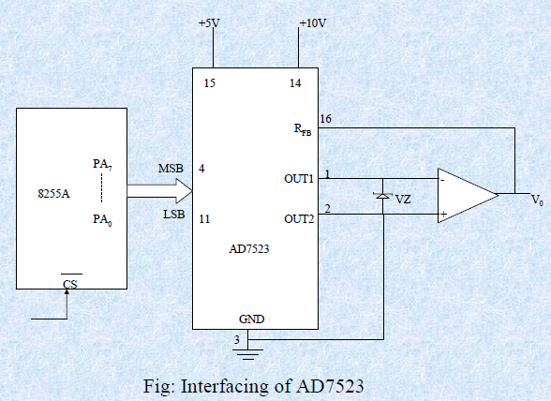
Figure:DAC connected with 8085 via 8255

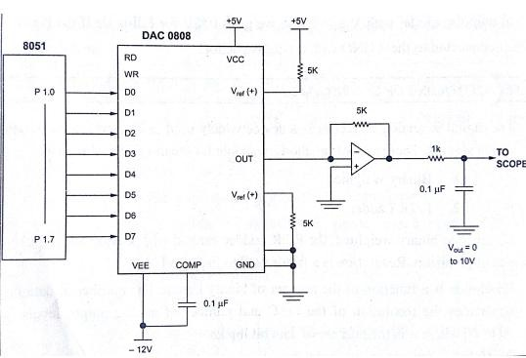
Figure:DAC connected with 8051
It also offers additional drive capability to the DAC output. An external feedback resistor acts to control the gain. One may not connect any external feedback resistor, if no gain control is required.
EXAMPLE: Interfacing DAC AD7523 with an 8085 CPU running at 8MHZ and write an assembly language program to generate a sawtooth waveform of period 1ms with V_{max} 5V.
Solution: Fig shows the interfacing circuit of AD 74523 with 8086 using 8255 program gives an ALP to generate a sawtooth waveform using circuit.
MOV A, 80h ;make all ports output
OUT C0, AL
AGAIN: MOV AL, 00H ;start voltage for ramp
BACK: OUT PA
INR A
CPI 0FFh
JB BACK
JMP AGAIN
In the above program, port A is initialized as the output port for sending the digital data as input to DAC.
- The ramp starts from the 0V (analog), hence AL starts with 00H. To increment the ramp, the content of AL is increased during each execution of loop till it reaches F2H.
- After that the saw tooth wave again starts from 00H, i.e. 0V (analog) and the procedure is repeated. The ramp period given by this program is precisely 1.000625 ms.
- Here the count F2H has been calculated by dividing the required delay of 1ms by the time required for the execution of the loop once.
- The ramp slope can be controlled by calling a controllable delay after the OUT instruction.
INTERFACING 8279 WITH 8085
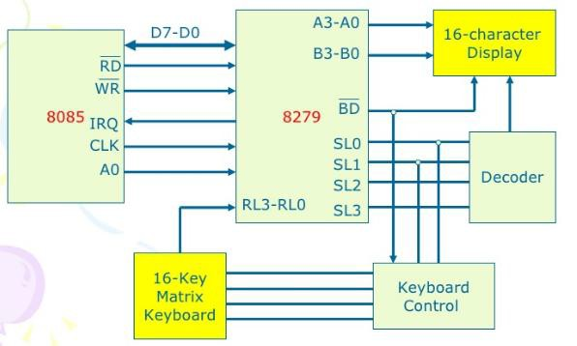
Interfacing 8254 with 8085
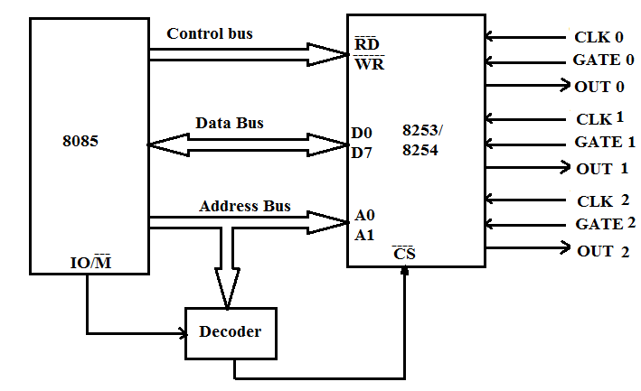

INTERFACING 8255 WITH 8085
8085 Microprocessor interfaced to the 8255.
  - Port A has been used as the input port for the security status, whereas, port B has been used as the output port for the command.
  - The port numbers assigned are 04 (port A), 05 (port B), 06 (port C) and 07 (Control Word) as evident from the circuit.

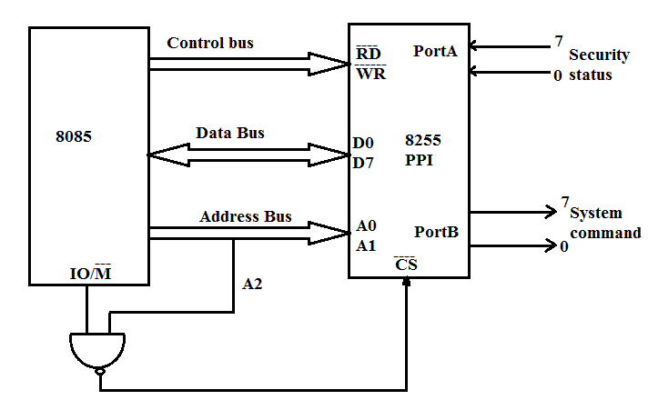

Explain the LED interfacing with 8086 microprocessor(April 2018)
******************************************************************************
Interfacing LED with 8086
LED (LIGHT EMITTING DIODES)
Light Emitting Diodes (LED) is the most commonly used components, usually for displaying pins digital states. Typical uses of LEDs include alarm devices, timers and confirmation of user input such as a mouse click or keystroke.
INTERFACING LED
Fig. 1 shows how to interface the LED to microprocessor. As you can see the Anode is connected through a resistor to GND & the Cathode is connected to the Microprocessor pin. So when the Port Pin is HIGH the LED is OFF & when the Port Pin is LOW the LED is turned ON.
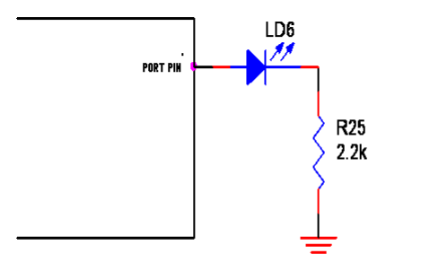
INTERFACING LED WITH 8086 We now want to flash a LED in 8086 Trainer Board. It works by turning ON a LED & then turning it OFF & then looping back to START. However the operating speed of microprocessor is very high
PIN ASSIGNMENT WITH 8086
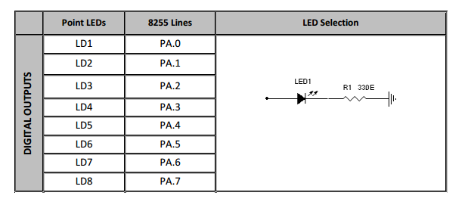

CIRCUIT DIAGRAM TO INTERFACE LED WITH 8255
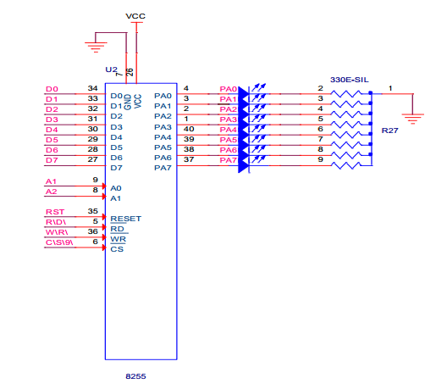
ASSEMBLY PROGRAM TO ON AND OFF LED USING 8086
Title : Program to Blink LEDs
